Share the Care Activity

Facilitator Guide

- Time: 30 minutes

- Audience: PGY-2 and PGY-3 (or late PGY-1), this is more interactive and engaging if it can non-resident providers and clinic staff.

- Objective:
  - Team Based Care: Describe and participate in sharing the care for patient panels through expanded team roles by working and communicating effectively with all health care team members

- Procedures:

Visual set up: The grid below can be drawn on large flip chart paper or white boards. Cups can be placed at bottom or tops of each column.(see photos below)
Role 1 | Role 2 | Role 3 | Role 4 | Role 5 | Role 6 | Role 7 | Role 8 | Role 9 | Role 10

Groups:

Part 1: Who does it now?

- Make sure your group has 2 sets of cards—role cards and task cards (see appendix below).

- Secure role cards at the top of each column. Each team should have 10 roles (thus, 10 columns).

- As a group, place each task card under a role based on who is currently doing this task at your clinic. Go through as many of the 22 tasks in the allotted time.

Note: In cases where there are group members from different clinics, place card based on the group majority. In cases where more than 1 role performs the task, choose 1 role to place task card under.

- When time is called, count the number of tasks in each role column.

- Place 5 marbles per task in the cup that corresponds to each role column.
Part 2: Who should complete these tasks?

- Reflect on what you have recently learned about team-based care and your group’s current assignment of task cards.

- As a group, reassess each task in an ideal team based care environment. Move task cards to a new role, if appropriate. Go through as many of the 22 tasks in the allotted time.

Note: In cases where more than 1 role can perform the task, choose 1 role to place task card under.

- When time is called, count the number of tasks in each role column.

- Reallocate the marbles to reflect shifts in tasks (5 marbles per task in a cup that corresponds to each role column).
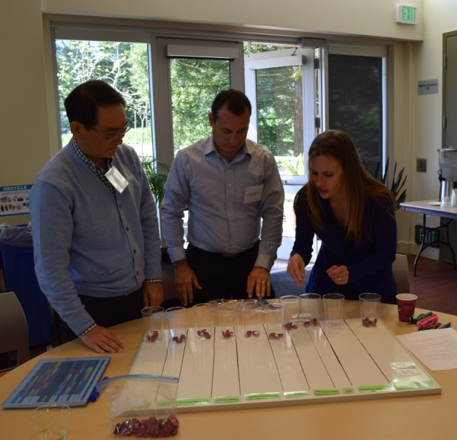
Appendix - Share the Care Activity
Role Cards:
Primary Care Provider  (MDs, DOs, NPs, PAs) | Resident Physician
MA/LPN/LVN | Clerk/Receptionist
Nobody | RN
Pharmacist | Behavioral Health
Health Coach | Patient

Task Cards:
Order mammograms for women 50-75 years of age | Discuss colorectal screening options with patients
Identify patients with overdue chronic disease related labs | Conduct depression screening
Conduct depression follow-up | Prescribe statins for patients with high ASCVD risk
Refill high blood pressure medications for patients with well-controlled hypertension | Refill narcotics for chronic pain patients
Warfarin management (anti- coagulation) | Titrate insulin for diabetic patients
Medication reconciliation for patient(s) | Order routine immunizations
Administer routine immunizations | Treat uncomplicated urinary tract infections
Assess and manage uncomplicated acute back pain | Counsel on and insert long acting contraception
Perform diabetic foot exams | Inform patients of normal lab test results
Inform patient(s) of abnormal lab test results | Review goals for labs and results of chronic disease management
Refer patients for subspecialty care | Obtain hospital/discharge information

Share the Care Activity

Evaluation

1) I understand how to work and communicate effectively with all health care team members to share the care for my patient panel.

Strongly Disagree | Disagree | Undecided | Agree | Strongly Agree
1 | 2 | 3 | 4 | 5

2) This activity enhanced my understanding.

Strongly Disagree | Disagree | Undecided | Agree | Strongly Agree
1 | 2 | 3 | 4 | 5

3) The information from this activity is relevant to my practice.

Strongly Disagree | Disagree | Undecided | Agree | Strongly Agree
1 | 2 | 3 | 4 | 5

