Medical Neighborhood Care Integration Assessment Group Activity
Facilitator Guide

- Time: 10-15 minutes per assessment tool domain and 30 minutes for discussion

- Audience: Late PGY-1 or PGY-2/PGY-3 that have worked in the primary care practice and been exposed to the broader medical neighborhood.

- Objectives: Describe the larger medical network they are a part of and recognize gaps and opportunities in care integration.

- Procedures:

Background:

- The Medical Neighborhood Care Integration Assessment (MNCI-A) is a self-assessment tool designed to help reveal the degree to which your primary care clinical practice is integrated into the broader “medical neighborhood.”
- It highlights evidence-based integration strategies that primary care practices can consider to enhance integration into the broader medical neighborhood.
- The questions focus on each of six domains of primary care integration (specialty care, oral health, diagnostic imaging, pharmacy care, hospital care, and behavioral health) as below:
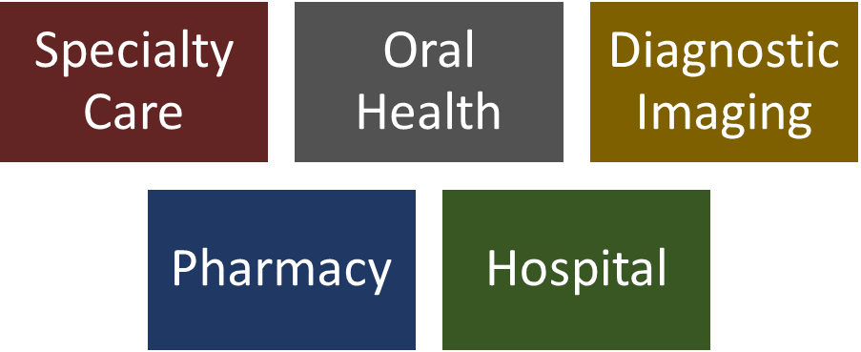

Recommended activity instructions:

- Alongside a representative sample of your clinic (i.e. leadership, management, non-resident providers, and/or staff) and resident providers, break up into small groups (2-3 people per group).
- Each small group can focus on assessing the domains of primary care integration. If you have enough people for 6 small groups, each group focuses on 1 domain. If only enough people for 3 small groups, each group focuses on 2 domains. You can also consider tackling just 1 domain initially.
- Each small group should select a timekeeper, a spokesperson, and survey responder/note taker.
- If your organization has multiple practice sites, select one site.
- The questions on overall success of integration are on a 1-10 point scale; questions on strategies used are on a 1-5 scale.
- Clinics that use this use the strategies for integration for future programming and do it on a regular basis to track improvement.
- Reference: http://www.careinnovations.org/uploads/Medical_Neighborhood_Care_Integration_Assessment_Final.pdf

Recommended discussion:

- After all of the groups fill out the specific domains of primary care integration they should come back as a large group.
- The spokesperson for each small group can report back to the group the overall success of integration for each domain and which strategies they think can be more widely employed in the clinic to increase the integration for each domain.

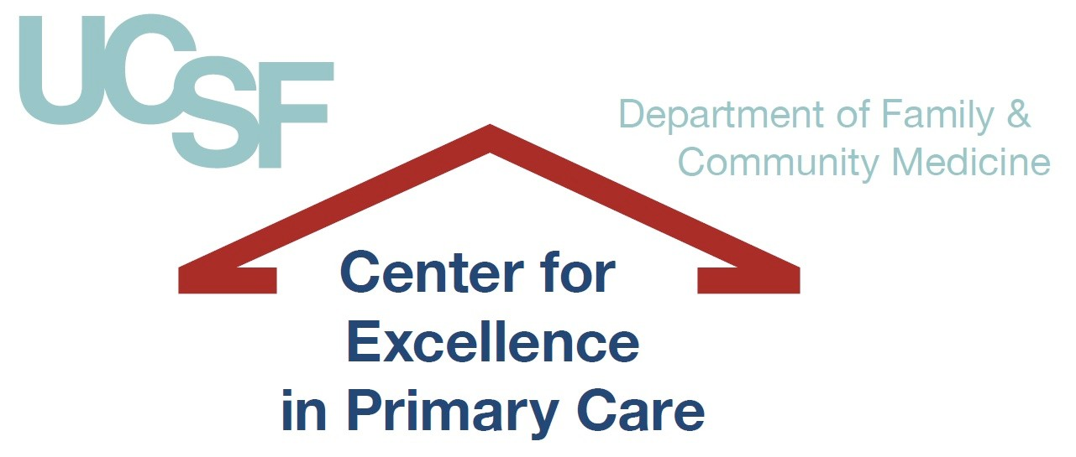

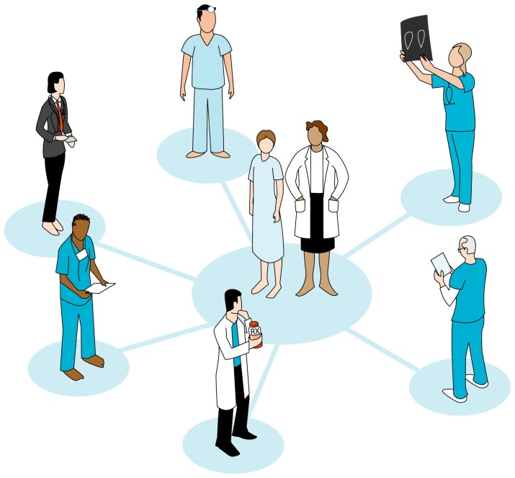
Medical Neighborhood Care Integration Assessment (MNCI7A)

Answer each question from the perspective of one physical site (e.g., a practice, clinic).
Date of assessment

Please provide name of your clinic/organization

Please list the roles of the team members completing this survey (e.g., clinician, nurse, manager, medical assistant)

Please note how many sites are part of your organization

If you have multiple sites, for which site(s) will you be responding? (Please name a specific site or write “ALL”)

What is the total number of FTE clinicians at that site?

What is the total number of patient visits per year at that site (if responding for ALL sites, please note total number of patient visits per year)?

Has your site or have your sites received PCMH recognition?

If so, at what level and from which organization?

Which of these categories best describes your clinical setting?
- FQHC or FQHC look alike, county based
- FQHC or FQHC look alike, non7county based
- Private practice
- Academic or faculty practice
- Hospital7based clinic
- Other 7

Primary Care* Specialty Integration:

Overall success of integration: How much do you agree or disagree with each of the following statements?
 | Strongly disagree |  |  |  |  |  |  |  |  | Strongly agree
a. Access: Most of the patients at my clinic have adequate access (i.e. timely access and affordable) to specialty services when they need them. | 1 | 2 | 3 | 4 | 5 | 6 | 7 | 8 | 9 | 10
b. Information access and transfer to the partner: When I refer patients to a specialist, the specialist has electronic access to the important information about the patient’s medical history and reason for referral. | 1 | 2 | 3 | 4 | 5 | 6 | 7 | 8 | 9 | 10
c. Information access and transfer by the primary care practice: After a patient sees a specialist, I receive timely information from the specialist about the assessment and care plan. | 1 | 2 | 3 | 4 | 5 | 6 | 7 | 8 | 9 | 10
d. Relationships: PCPs at my practice have a good working relationship with most of the specialty care providers involved in our patients’ care. | 1 | 2 | 3 | 4 | 5 | 6 | 7 | 8 | 9 | 10

Strategies used: Which of the following strategies does your practice use to integrate primary care and specialty care services, and to what degree?

 | Strategy not used at all |  |  |  | Strategy used extensively
a. Specialists provide services on site at our primary care practice. | 1 | 2 | 3 | 4 | 5
b. Our practice has expanded PCP procedural capacity in the following:
a. Colonoscopy | 1 | 2 | 3 | 4 | 5
b. Cardiac stress testing | 1 | 2 | 3 | 4 | 5
c. Colposcopy | 1 | 2 | 3 | 4 | 5
d. Flexible sigmoidoscopy | 1 | 2 | 3 | 4 | 5
e. Basic Dermatology procedures (biopsies, excisions, etc.) | 1 | 2 | 3 | 4 | 5
f. Retinal screening | 1 | 2 | 3 | 4 | 5
g. Other | 1 | 2 | 3 | 4 | 5
c. Our practice has enhanced our PCPs’ ability to be the principal clinician managing the following conditions:
a. HIV/AIDS | 1 | 2 | 3 | 4 | 5
b. Hepatitis C | 1 | 2 | 3 | 4 | 5
c. Hepatitis B | 1 | 2 | 3 | 4 | 5

d. Depression and/or anxiety | 1 | 2 | 3 | 4 | 5
e. Chronic Pain | 1 | 2 | 3 | 4 | 5
d. Our practice has developed written agreements with specialists about expectations for access and communication. | 1 | 2 | 3 | 4 | 5
e. Our practice uses care coordinators, patient navigators, or dedicated referral coordinators to coordinate and facilitate referrals to specialty services and patient attendance at referral appointments. | 1 | 2 | 3 | 4 | 5
f. Our practice increases the availability and coordination of specialty care through the following telemedicine modalities:
a. Electronic consultations (eConsults, eReferrals) | 1 | 2 | 3 | 4 | 5
b. store and forward technology (e.g., digital images of retinas or skin lesions) | 1 | 2 | 3 | 4 | 5
c. real time video consultation | 1 | 2 | 3 | 4 | 5

Primary Care* Oral Health Integration:

Overall success of integration: How much do you agree or disagree with each of the following statements?
 | Strongly disagree |  |  |  |  |  |  |  |  | Strongly agree
a. Access: Most of our adult patients have access to timely and affordable basic dental services. | 1 | 2 | 3 | 4 | 5 | 6 | 7 | 8 | 9 | 10
b. Access: Most of our Pediatric patients have access to timely and affordable basic dental services. | 1 | 2 | 3 | 4 | 5 | 6 | 7 | 8 | 9 | 10
c. Access: Most of the patients at my clinic have adequate access to emergent or urgent dental services when they need them. | 1 | 2 | 3 | 4 | 5 | 6 | 7 | 8 | 9 | 10
d. Access: Most of the patients at my clinic have adequate access to preventive and/or rehabilitative dental services when they need them. | 1 | 2 | 3 | 4 | 5 | 6 | 7 | 8 | 9 | 10
e. Relationships: PCPs at my practice have a good working relationship with most of the dentists involved in our patients’ care. | 1 | 2 | 3 | 4 | 5 | 6 | 7 | 8 | 9 | 10

Strategies used: Which of the following strategies does your practice use to integrate primary care and oral health services and to what degree?

 | Strategy not used at all |  |  |  | Strategy used extensively
a. Dental services for adults are offered on site at our practice. | 1 | 2 | 3 | 4 | 5
b. Dental services for children are offered on site at our practice. | 1 | 2 | 3 | 4 | 5
c. Our site has specific protocols for integrating primary care and oral health care. | 1 | 2 | 3 | 4 | 5
d. Administration of fluoride varnish is integrated into routine well child visits in our primary care practice. | 1 | 2 | 3 | 4 | 5
e. Dental screening exams (i.e. visual inspection) are integrated into routine well child visits in our primary care practice. | 1 | 2 | 3 | 4 | 5
f. Our practice works with a defined network of dental care providers to ensure adequate access to dental services. | 1 | 2 | 3 | 4 | 5
g. Our practice has developed written agreements with dentists about expectations for access and communication. | 1 | 2 | 3 | 4 | 5
h. Our practice provides or refers patients to mobile dental services in the community or near our health center. | 1 | 2 | 3 | 4 | 5

i. Our practice engages patients in oral health through education and self-management support. | 1 | 2 | 3 | 4 | 5
j. Our practice increases the availability and coordination of oral health services through tele-dentistry. | 1 | 2 | 3 | 4 | 5
k. Our practice provides School-Based dental services in our local community. | 1 | 2 | 3 | 4 | 5

Primary Care* Diagnostic Imaging Integration:

Overall success of integration: How much do you agree or disagree with each of the following statements?
 | Strongly disagree |  |  |  |  |  |  |  |  | Strongly agree
a. Access: Most of the patients at my clinic have adequate access (i.e timely and affordable) to diagnostic imaging services when they need them:
d. For low cost diagnostic imaging services such as x-rays | 1 | 2 | 3 | 4 | 5 | 6 | 7 | 8 | 9 | 10
e. For high cost diagnostic imaging services such as CT, MRI, etc. | 1 | 2 | 3 | 4 | 5 | 6 | 7 | 8 | 9 | 10
b. Information access and transfer by the primary care practice: Patient diagnostic imaging results are consistently available to the primary care practice when they are available. | 1 | 2 | 3 | 4 | 5 | 6 | 7 | 8 | 9 | 10

c. Relationships: PCPs at my clinic have a good working relationship with most of the diagnostic imaging providers involved in our patients’ care. | 1 | 2 | 3 | 4 | 5 | 6 | 7 | 8 | 9 | 10

Strategies used: Which of the following strategies does your practice use to integrate primary care and diagnostic imaging services and to what degree?

 | Strategy not used at all |  |  |  | Strategy used extensively
a. Diagnostic imaging services are offered on site at our practice:
a. for low cost diagnostic imaging services such as x-rays | 1 | 2 | 3 | 4 | 5
b. for high cost diagnostic imaging services such as CT, MRI, etc. | 1 | 2 | 3 | 4 | 5
b. Our practice assists patients in obtaining private facility discounts for imaging services. | 1 | 2 | 3 | 4 | 5
c. Our practice has a collaborative agreement with a hospital or academic medical center that improves patient access to imaging services. | 1 | 2 | 3 | 4 | 5
d. Our practice has developed written agreements with sites offering diagnostic imaging services about expectations for access and communication. | 1 | 2 | 3 | 4 | 5
e. We refer our patients to a hospital or organizations where free or reduced-cost imaging services are available for the uninsured. | 1 | 2 | 3 | 4 | 5

f. Our practice uses referral coordinators, care coordinators or patient navigators who track diagnostic test referrals. | 1 | 2 | 3 | 4 | 5
g. Our practice uses referral guidelines to guide the referral and use of diagnostic imaging services. | 1 | 2 | 3 | 4 | 5

Primary Care* Pharmacy Integration:

Overall success of integration: How much do you agree or disagree with each of the following statements?
 | Strongly disagree |  |  |  |  |  |  |  |  | Strongly agree
a. Access: Most of the patients at my clinic have timely and affordable access to pharmacy services (i.e. medications and medication counseling) when they need them. | 1 | 2 | 3 | 4 | 5 | 6 | 7 | 8 | 9 | 10
b. Relationships: PCPs at my practice have a good working relationship with most of the pharmacies involved in our patients’ care. | 1 | 2 | 3 | 4 | 5 | 6 | 7 | 8 | 9 | 10
c. Information access and transfer by the primary care practice: Our practice is able to access information about fill rates for prescribed medications and receive alerts when medications are not filled or picked up. | 1 | 2 | 3 | 4 | 5 | 6 | 7 | 8 | 9 | 10
d. Information access and transfer: Our practice is able to communicate bi-directionally with pharmacies for electronic prescribing and refill requests. | 1 | 2 | 3 | 4 | 5 | 6 | 7 | 8 | 9 | 10

Strategies used: Which of the following strategies does your practice use to integrate primary care and pharmacy services and to what degree?

 | Strategy not used at all |  |  |  | Strategy used extensively
a. Our practice has an in-clinic pharmacy through the federal 340B pricing program or some other pricing arrangement. | 1 | 2 | 3 | 4 | 5
b. Our practice offers in-clinic medication therapy management (MTM), in which pharmacists collaborate with primary care providers to review and manage patient medications. | 1 | 2 | 3 | 4 | 5
c. Our practice has developed written agreements with pharmacies about expectations for access and communication. | 1 | 2 | 3 | 4 | 5
d. Patient navigators or dedicated staff members in our practice help patients enroll in pharmaceutical company administered patient assistance programs. | 1 | 2 | 3 | 4 | 5
e. Our practice refers patients to pharmacies that offer medication therapy management, in which pharmacists collaborate with primary care providers to review and manage patient medications. | 1 | 2 | 3 | 4 | 5
f. We are able to secure medication organization services (e.g., daily dose bubble packs) from the pharmacy for our patients who need assistance. | 1 | 2 | 3 | 4 | 5
g. We are able to secure prescription labeling and instruction in a patient’s preferred language from the pharmacy for most of our patients. | 1 | 2 | 3 | 4 | 5

Primary Care* Hospital Integration:

Overall success of integration: How much do you agree or disagree with each of the following statements?
 | Strongly disagree |  |  |  |  |  |  |  |  | Strongly agree
a. Information Access and Transfer to the partner: When one of our patients goes to the hospital, hospital staff are able to access important information about the patient’s medical history from our medical records. | 1 | 2 | 3 | 4 | 5 | 6 | 7 | 8 | 9 | 10
b. Information Access and Transfer to the primary care practice: Our staff has timely access to important information from the hospitalization, including follow up and discharge plans, and results of laboratory or diagnostic testing performed in the hospital. | 1 | 2 | 3 | 4 | 5 | 6 | 7 | 8 | 9 | 10
b. Our primary care physicians do not provide direct inpatient care for our hospitalized patients but perform “social rounding” to keep them engaged in the hospital care process. 1 2 3 4 5  c. Primary care providers in our practice speak directly with hospitalists when their patients are admitted and/or discharged. 1 2 3 4 5  d. Our practice exchanges patient information electronically with most or all local hospitals where our patients receive hospital care. 1 2 3 4 5  e. Our practice has built written agreements with hospitals about expectations for access and communication. 1 2 3 4 5  d. Our practice is notified by the hospital when our patients are discharged. 1 2 3 4 5  e. Hospital based care coordinators discuss the hospital care plan and promote timely outpatient follow-up with the primary care medical home. 1 2 3 4 5  f. Nursing or other staff in our practice coordinate care transitions from the hospital by contacting recently discharged patients to conduct reconcile medications, provide self-management support, ensure receipt of hospital records, and encourage follow-up care. 1 2 3 4 5  g. Our practice ensures that patients discharged from the hospital are scheduled for visits at their primary care clinic within 7 days of discharge. 1 2 3 4 5  c. Relationships: PCPs at my practice have a good working relationship with most of the hospital providers involved in our patients’ care. | 1 | 2 | 3 | 4 | 5 | 6 | 7 | 8 | 9 | 10

Strategies used: Which of the following strategies does your practice use to integrate primary care and hospital services and to what degree?
 | Strategy not used at all |  |  |  | Strategy used extensively
a. Our primary care physicians provide direct inpatient care to our patients in the hospital and have primary responsibility for inpatient management. | 1 | 2 | 3 | 4 | 5

b. Our primary care physicians do not provide direct inpatient care for our hospitalized patients but perform “social rounding” to keep them engaged in the hospital care process. | 1 | 2 | 3 | 4 | 5
c. Primary care providers in our practice speak directly with hospitalists when their patients are admitted and/or discharged. | 1 | 2 | 3 | 4 | 5
d. Our practice exchanges patient information electronically with most or all local hospitals where our patients receive hospital care. | 1 | 2 | 3 | 4 | 5
e. Our practice has built written agreements with hospitals about expectations for access and communication. | 1 | 2 | 3 | 4 | 5
d. Our practice is notified by the hospital when our patients are discharged. | 1 | 2 | 3 | 4 | 5
e. Hospital based care coordinators discuss the hospital care plan and promote timely outpatient follow-up with the primary care medical home. | 1 | 2 | 3 | 4 | 5
f. Nursing or other staff in our practice coordinate care transitions from the hospital by contacting recently discharged patients to conduct reconcile medications, provide self-management support, ensure receipt of hospital records, and encourage follow-up care. | 1 | 2 | 3 | 4 | 5
g. Our practice ensures that patients discharged from the hospital are scheduled for visits at their primary care clinic within 7 days of discharge. | 1 | 2 | 3 | 4 | 5

Primary Care* Behavioral Health Integration:

Overall success of integration: How much do you agree or disagree with each of the following statements?
 | Strongly disagree |  |  |  |  |  |  |  |  | Strongly agree
a. Access: Most of the patients at my clinic have adequate access to behavioral services when they need them:
a. Children | 1 | 2 | 3 | 4 | 5 | 6 | 7 | 8 | 9 | 10
b. Adults | 1 | 2 | 3 | 4 | 5 | 6 | 7 | 8 | 9 | 10
c. Patients with serious mental illness | 1 | 2 | 3 | 4 | 5 | 6 | 7 | 8 | 9 | 10
b. Access: Most of the patients at my clinic have adequate access to behavioral services when they need them:
a. Behavioral counseling through Social Workers, Psychologists, and/or therapists | 1 | 2 | 3 | 4 | 5 | 6 | 7 | 8 | 9 | 10
b. Psychiatrist treatment and psychotropic medication management | 1 | 2 | 3 | 4 | 5 | 6 | 7 | 8 | 9 | 10
c. Management of dual-diagnoses (substance abuse, addiction, etc.) | 1 | 2 | 3 | 4 | 5 | 6 | 7 | 8 | 9 | 10
c. Relationships: PCPs at my practice have a good working relationship with the behaviorists involved in our patients’ care. | 1 | 2 | 3 | 4 | 5 | 6 | 7 | 8 | 9 | 10

Strategies used: Which of the following strategies does your practice use to integrate primary care and specialty care services and to what degree?

 | Strategy not used at all |  |  |  | Strategy used extensively
a. Behavioral health services co-located on site at our primary care practice. | 1 | 2 | 3 | 4 | 5
b. Behavioral health providers participate in team huddles and are considered part of the care team. | 1 | 2 | 3 | 4 | 5
c. Our practice has developed written agreements with behaviorists about expectations for access and communication. | 1 | 2 | 3 | 4 | 5
d. Our primary care teams provide screening for behavioral health conditions such as depression, anxiety, substance abuse, developmental delay, etc. | 1 | 2 | 3 | 4 | 5
e. Our primary care teams provide some substance abuse treatment in the clinic (i.e. buprenorphine, naloxone, etc.). | 1 | 2 | 3 | 4 | 5
f. Our primary care providers provide brief interventions for patients who screen positive for certain behavioral health conditions. | 1 | 2 | 3 | 4 | 5
g. Our primary care providers can make “warm handoffs” in clinic to behavioral health staff on an unscheduled basis. | 1 | 2 | 3 | 4 | 5
h. Our practice uses telemedicine to improve access to behavioral health:
a. Real time, video consultation | 1 | 2 | 3 | 4 | 5
b. Electronic consultations | 1 | 2 | 3 | 4 | 5
i. q. Our practice provides school based behavioral health services within our community. | 1 | 2 | 3 | 4 | 5

